Result when passing full name:

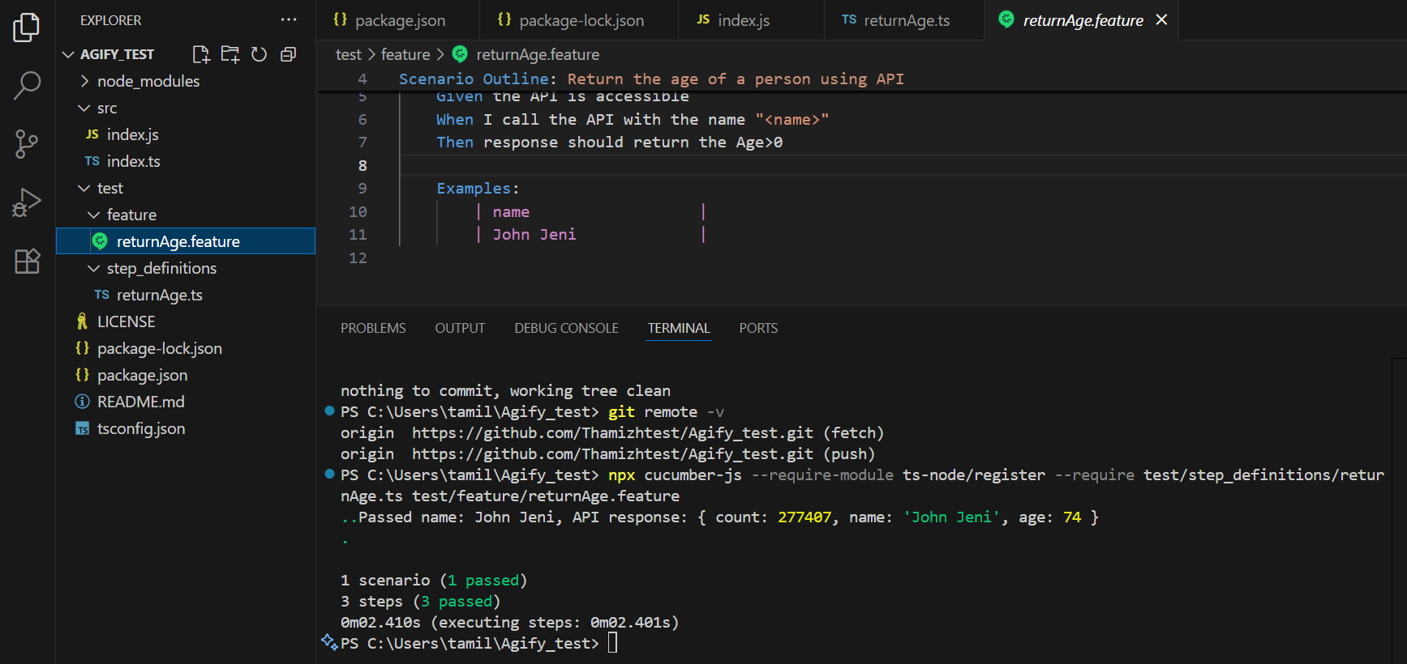

Result when passing First Name

Result when I pass name along with middle name:

Result when I don’t pass name: I should get an error as “Missing ‘name’ parameter



